JENKINS TASK 02

1) Configure 2 slave machines in Jenkins master.
2) Configure webhooks to Jenkins job.
3) Configure poll scm and build periodical options in Jenkins job.
4) Take backup of Jenkins server by using bash script.
5) Take backup of Jenkins using rethin backup plugin.
6) Setup a new Jenkins server and dump the backup taken in task4

- Configure 2 slave machines in Jenkins master.
Step 1) Create Ec2 instance
Do ssh to slave
Connect to root user
Install Java
sudo yum install -y java-17-amazon-corretto-devel
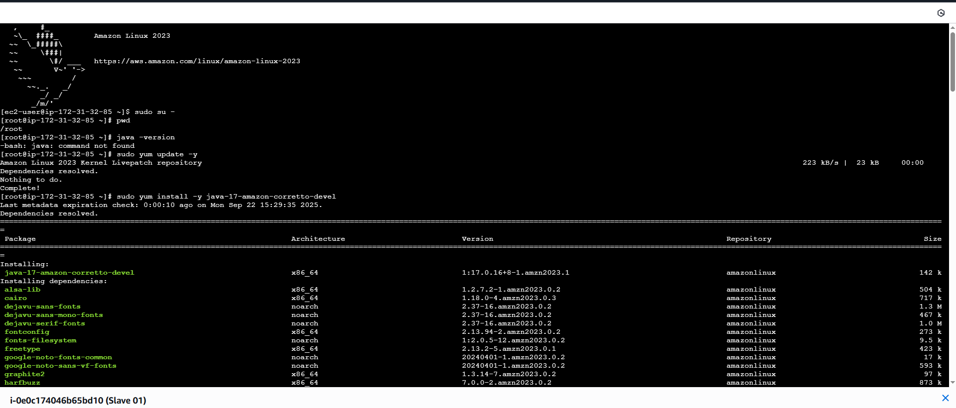

Step 2)
Create ssh-keygen(to make sure of password less authentication)
Cat id_rsa.pub > authorized_keys
Give permissions chmod 700 authorized_keys
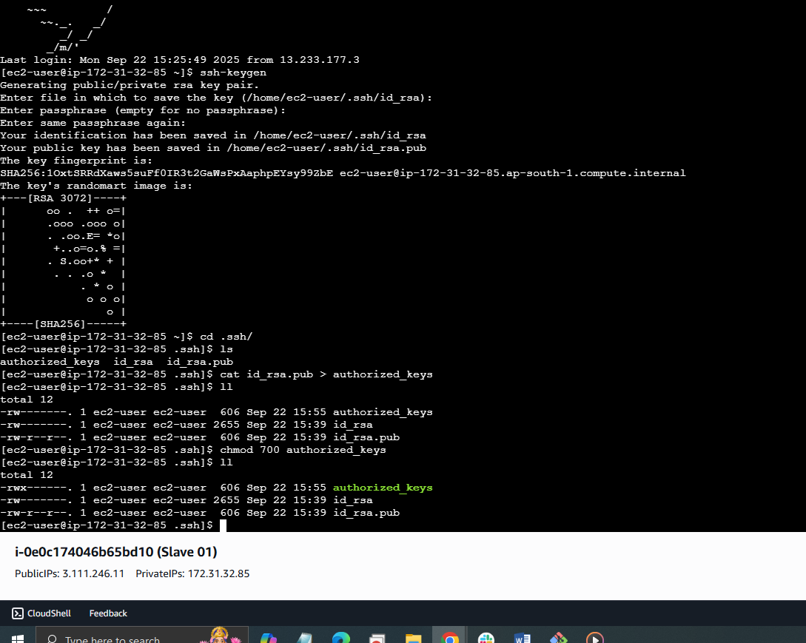

Steps to done in Master Machine
Login to Master Machine
Switch to root user
Create .SSH directory (cd /var/lib/Jenkins)
Ssh keyscan –H slave public ip >>/var/lib/Jenkins/.ssh/known_hosts
It will create known_hosts
Changeowner
Chown Jenkins:Jenkins known_hosts
Give permission chmod 700 known_hosts

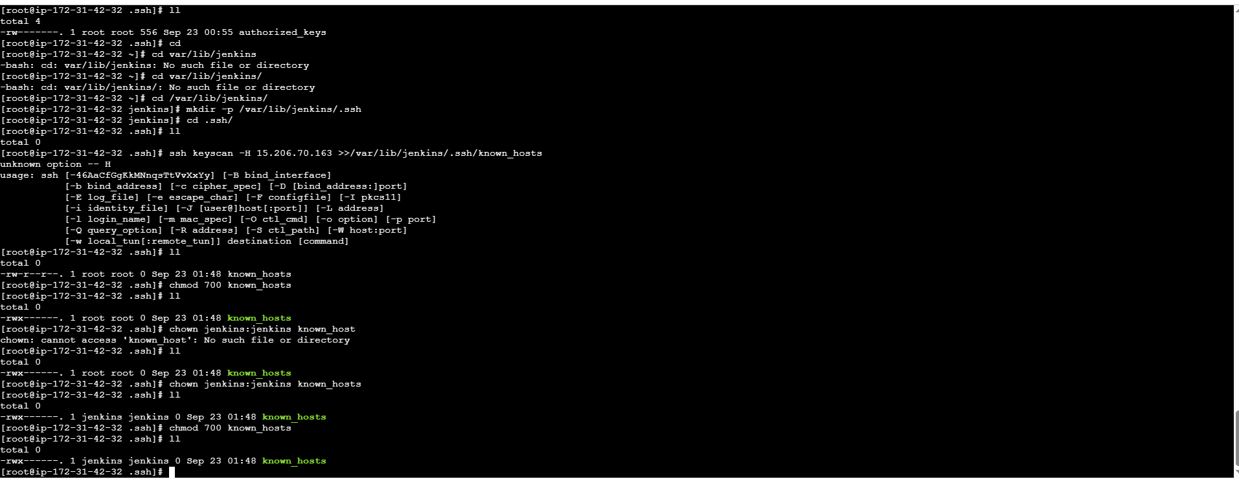
Next go to Jenkins GUI
1. Go to Manage Jenkins → Manage Nodes and Clouds →
New
Node
Give it a name (e.g., slave-01)
Select Permanent Agent
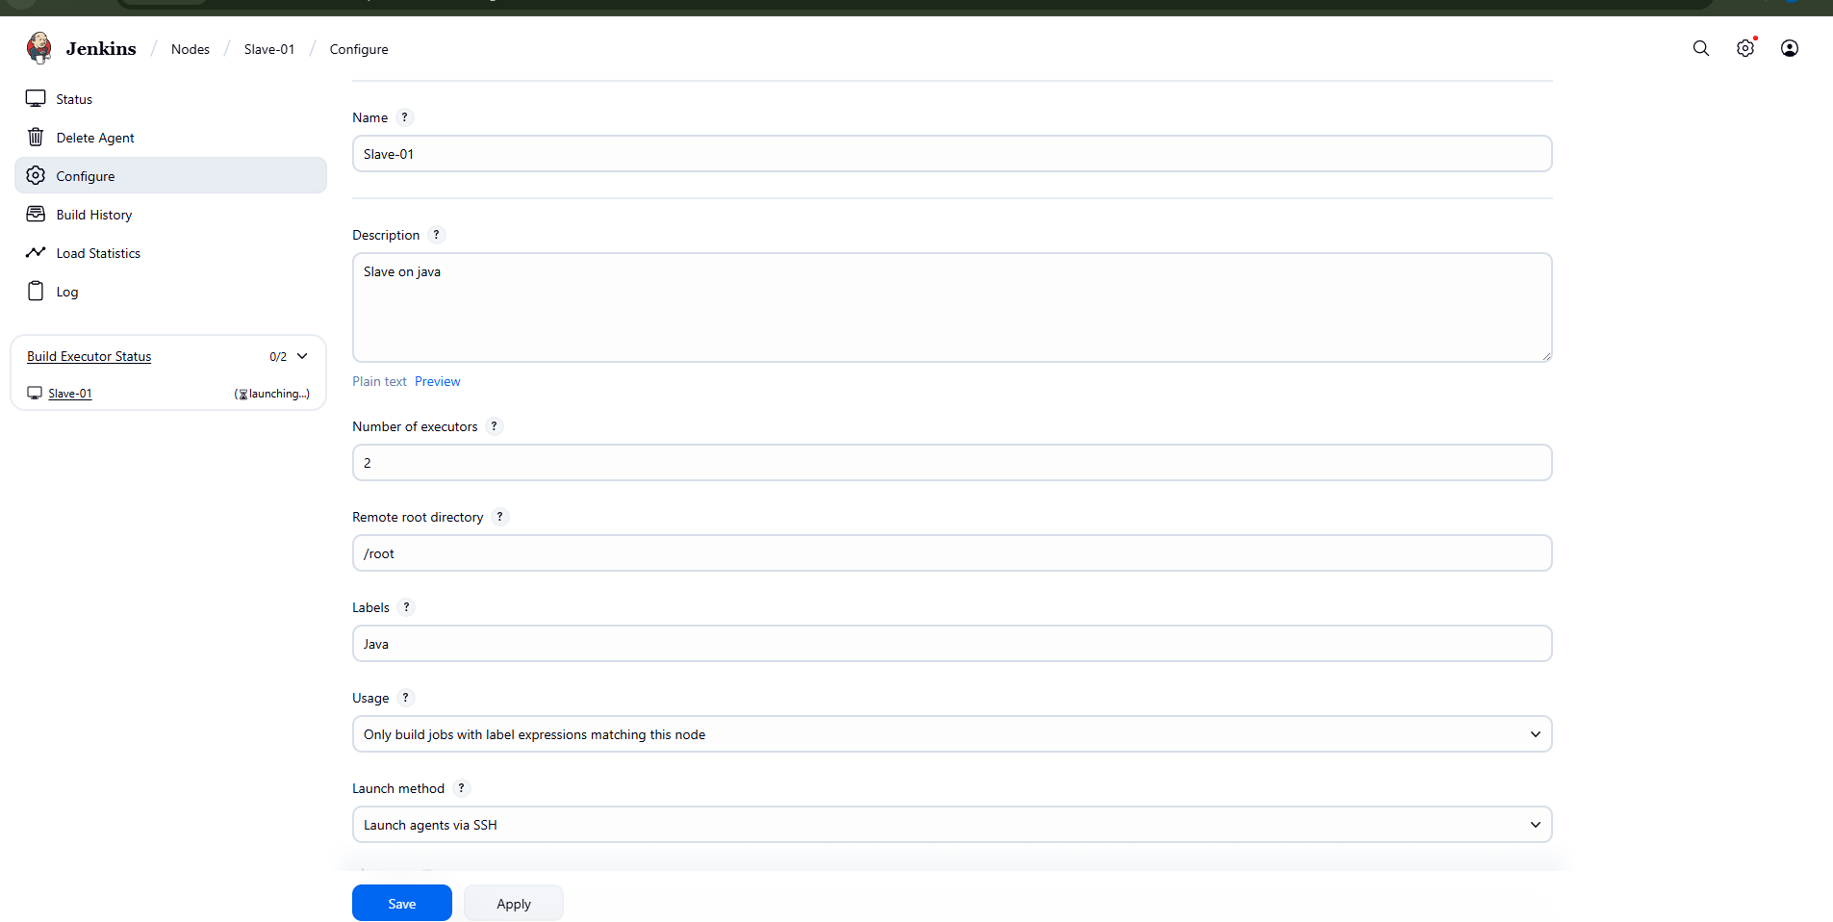
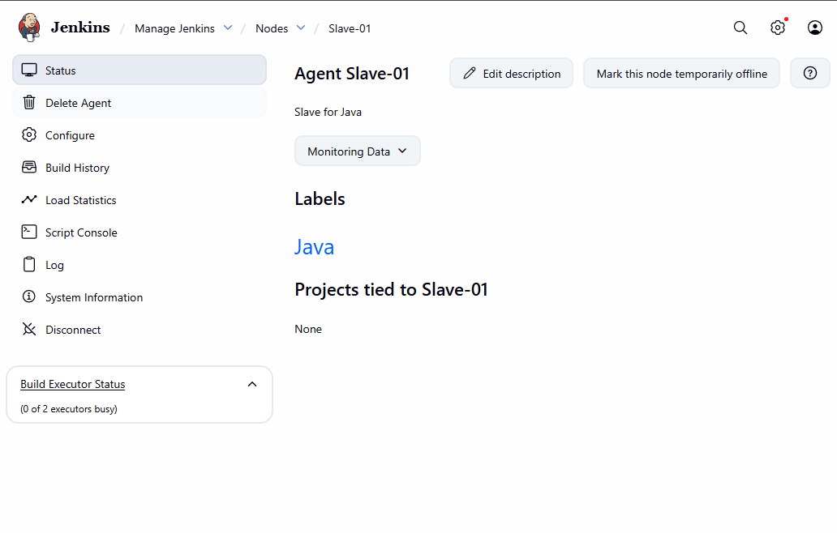
Let’s test with Label Java
Create a New Freestyle Job and Check
1. Go to Jenkins → New Item.
2. Enter a job name.
3. Select Freestyle project → Click OK.
4. Configure Job to Run on Slave
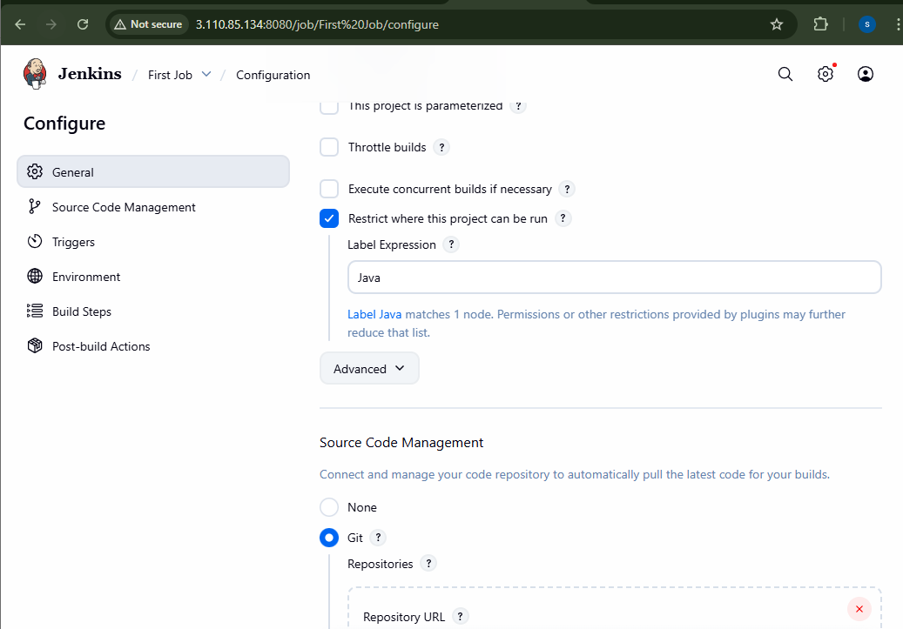

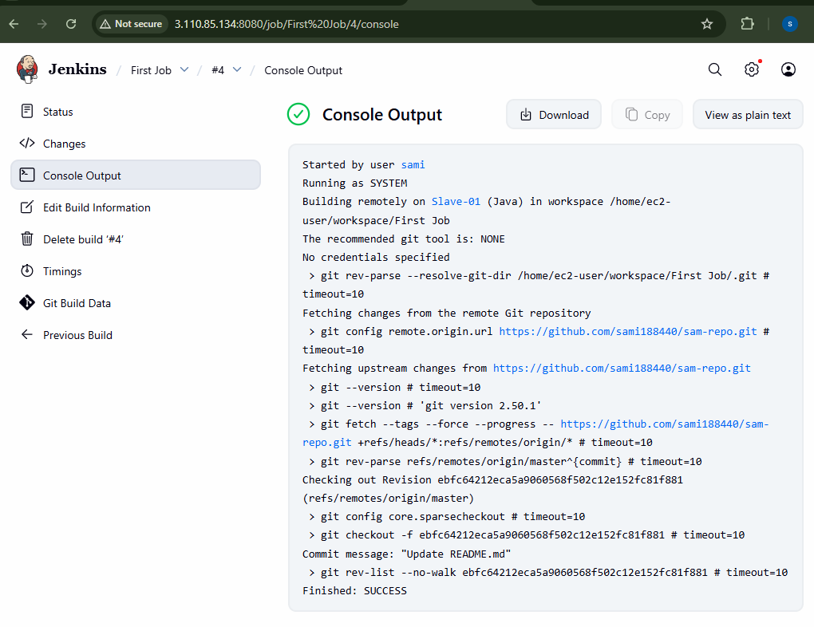

- Configure webhooks to Jenkins job.

To Configure Webhooks go to code in github Settings go to Webhook add webhook in pay load URL (configure Jenkins URL) after done it will send message
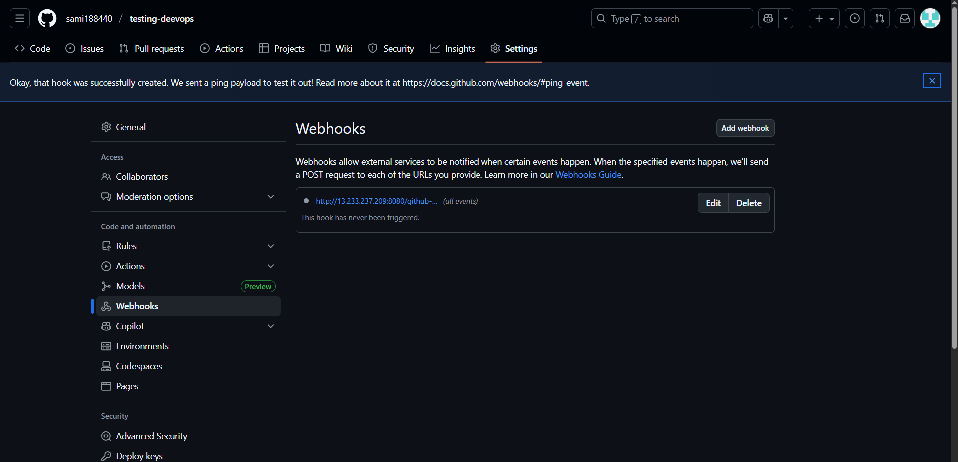

Go to Jenkins GUI
Create new item (sample-01)
Go to build trigger select
Git hook trigger for GITscm Polling
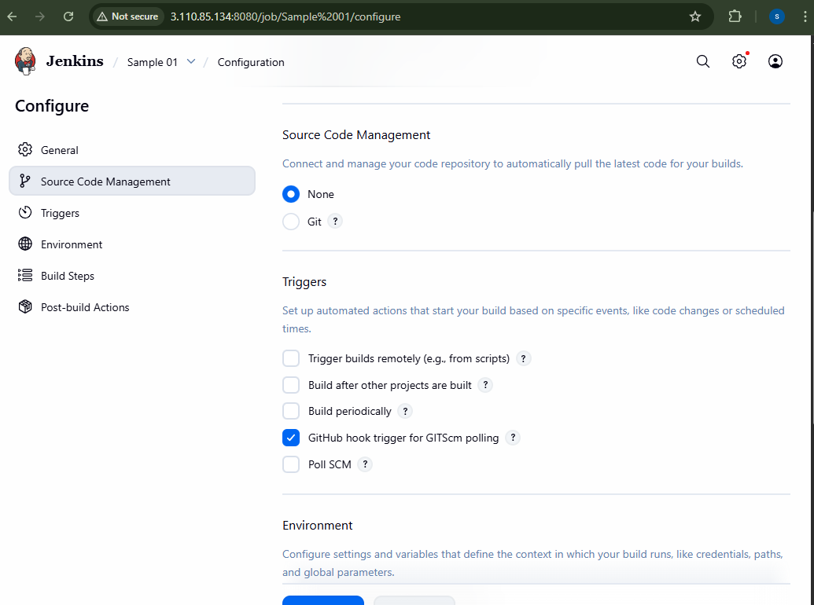
Verify:
Make changes in GIT repo
It will automatically trigger
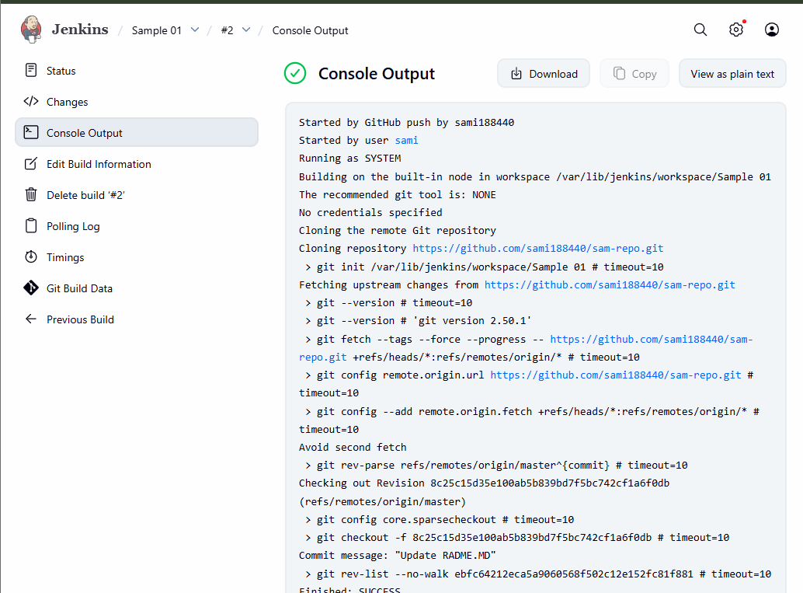

- Configure poll scm and build periodical options in Jenkins job.
Poll SCM → Builds only when there are code changes.
Build periodically → Builds at scheduled times whether code changes or not

Build Periodically
Whether there is change or no change it should trigger on scheduled time
Go Jenkins-New item create
Select in build triggers
Select Build Periodically
Enter corn style
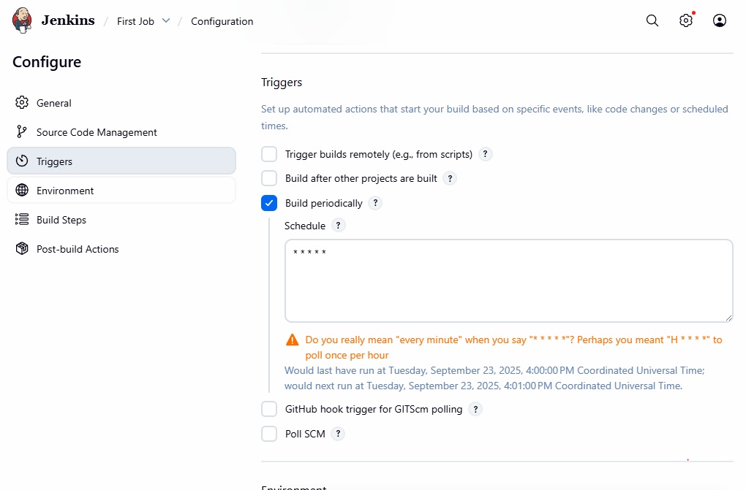
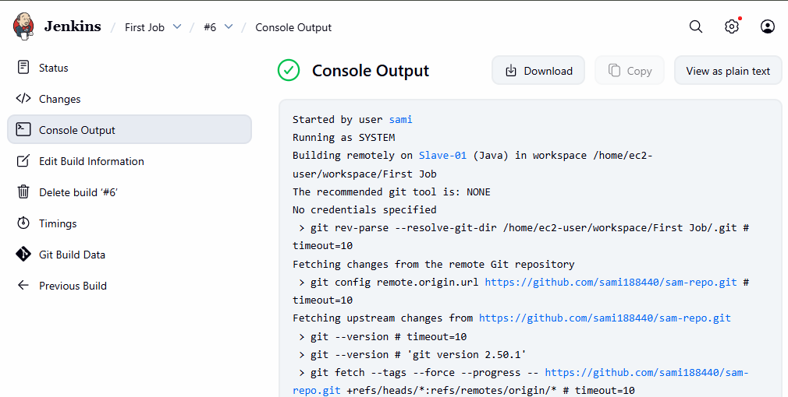
Poll SCM → Builds only when there are code changes then only it will trigger

Go to Jenkins
Select in triggers poll SCM
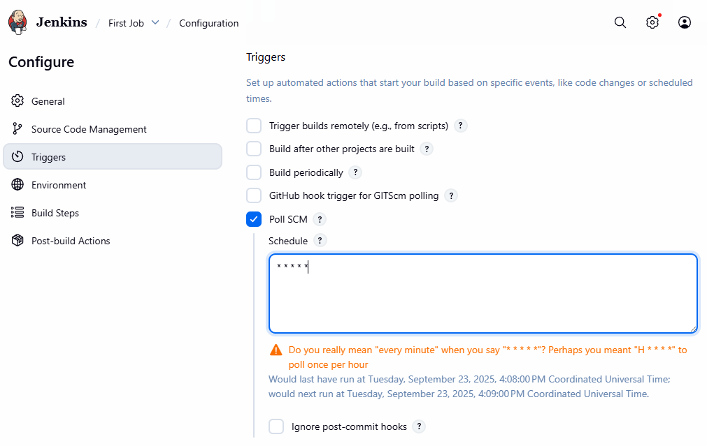Enter corn style
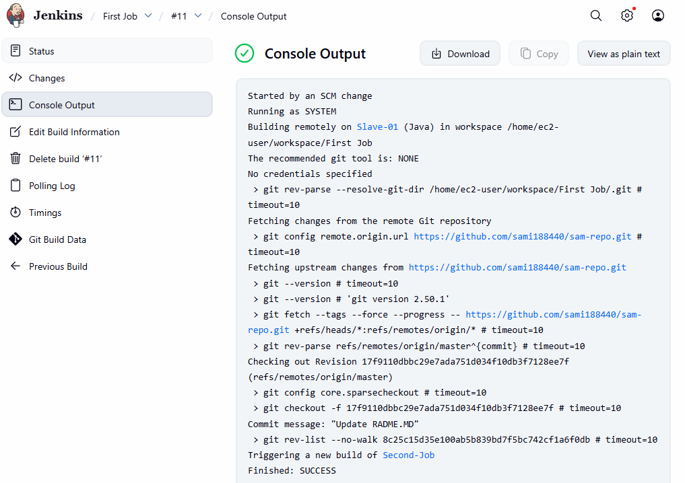
- Take backup of Jenkins server by using bash script.
Login to Jenkins root user
Vi Jenkins-backup.sh
Make script executable
Chmod +x Jenkins-backup.sh
To run script
./Jenkins-backup.sh
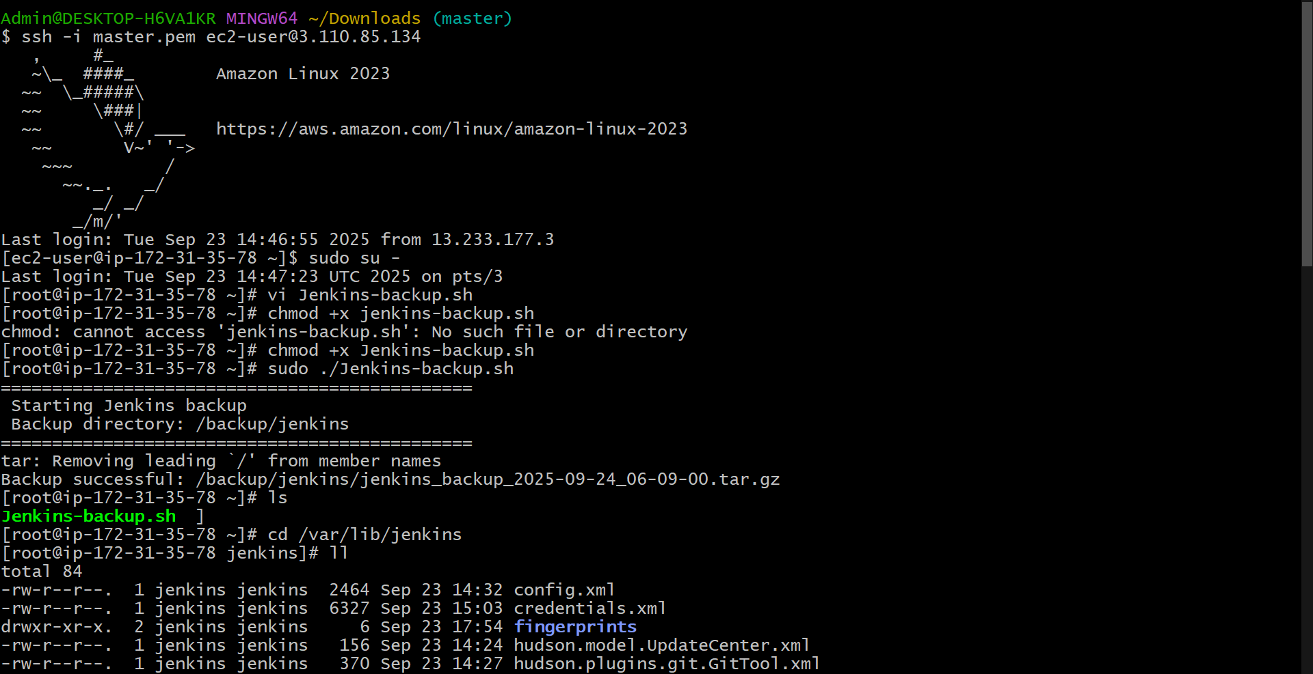

- Take backup of Jenkins using rethin backup plugin.

Step 01
Login to Jenkins
Step 2
Go to Plugins install Thinbackup plugin
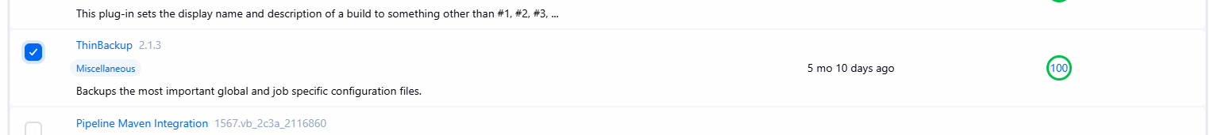
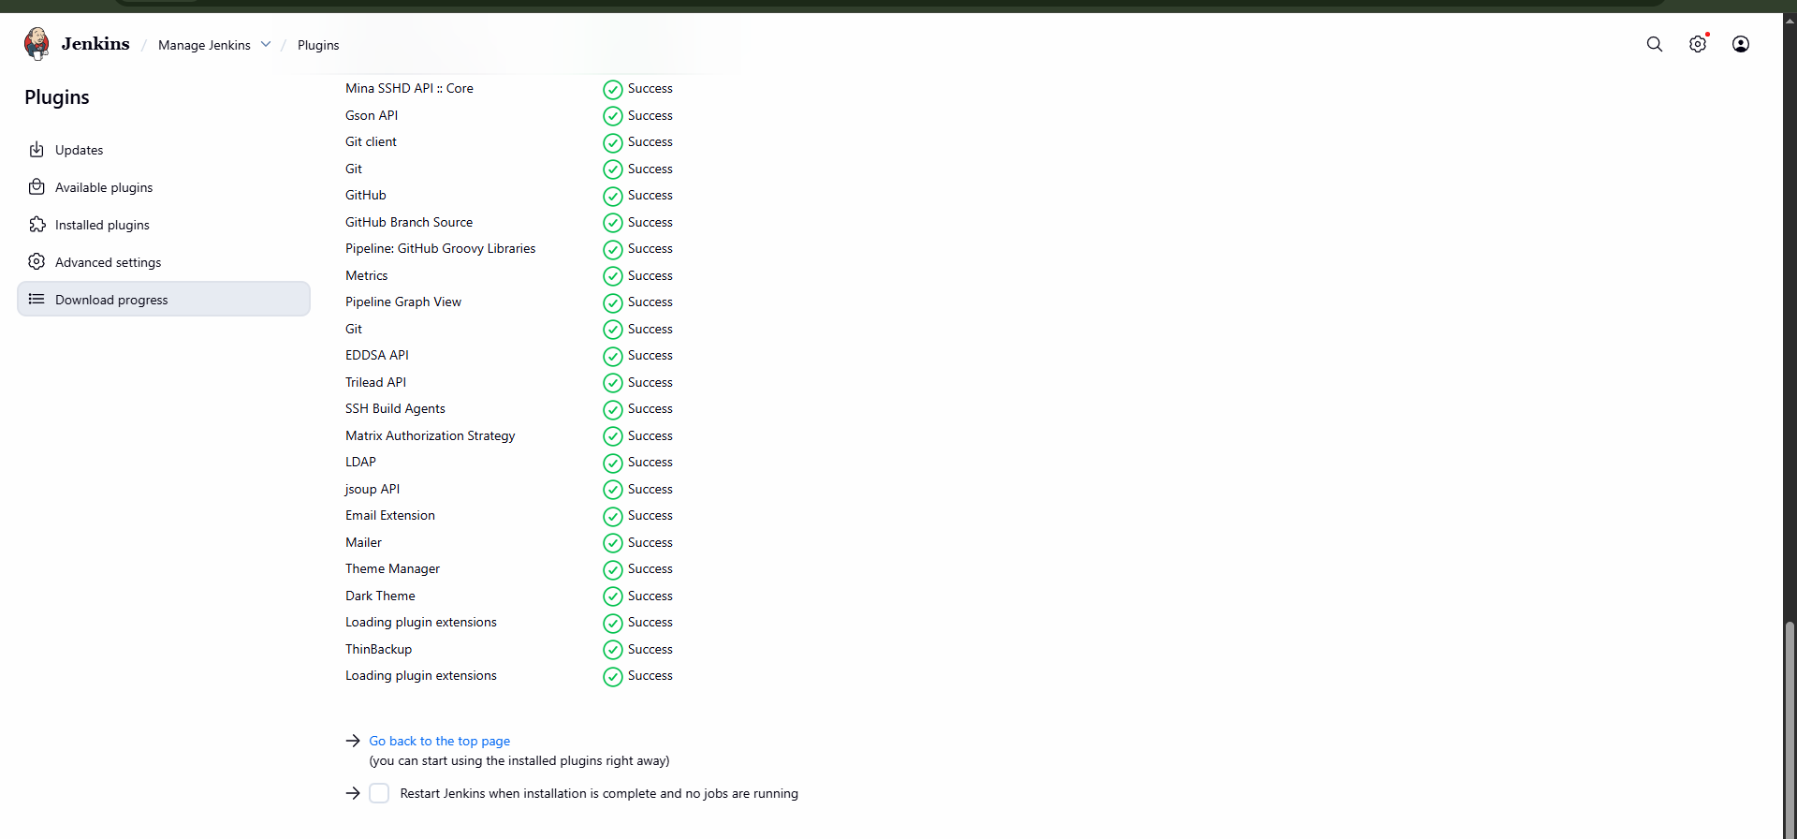
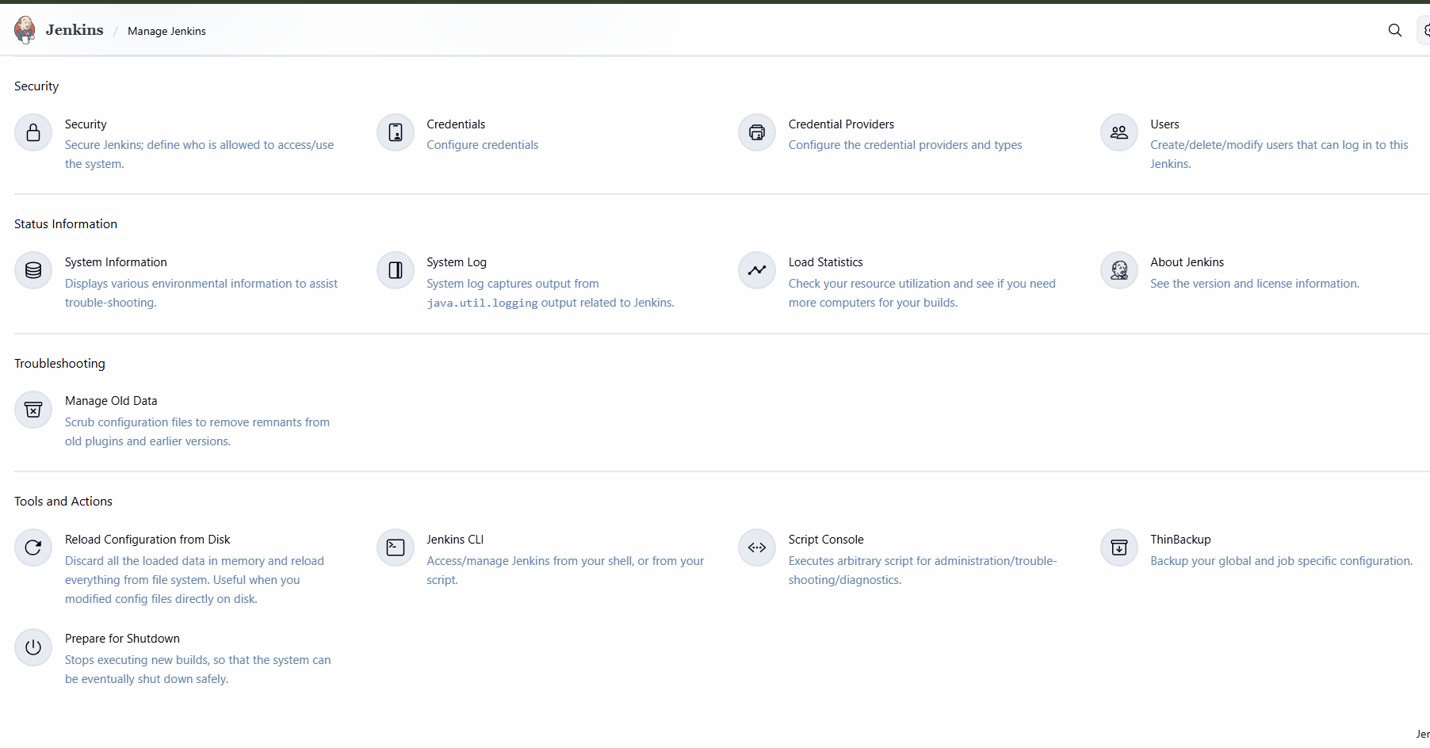
Trying to download

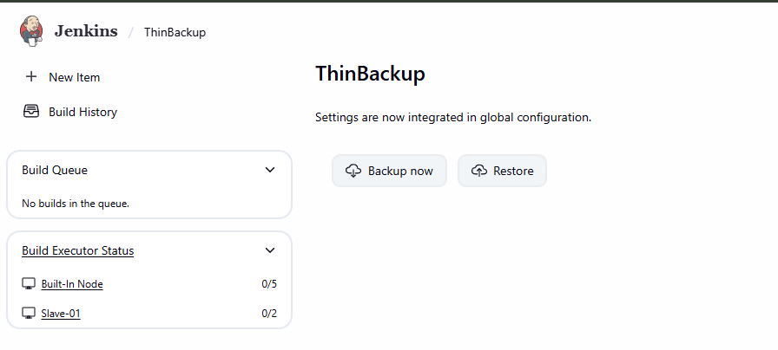
- Setup a new Jenkins server and dump the backup taken in task4
Step 1: Launch New Server & Install Jenkins
1. Launch a new EC2 instance name it Jenkins back-up
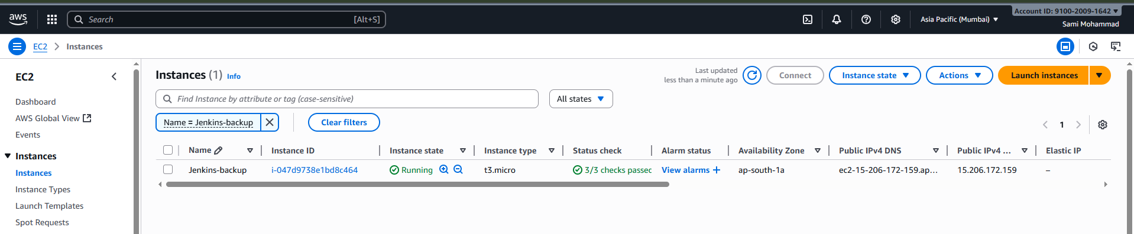2. Install Java (required for Jenkins)
sudo dnf install -y java-17-amazon-corretto
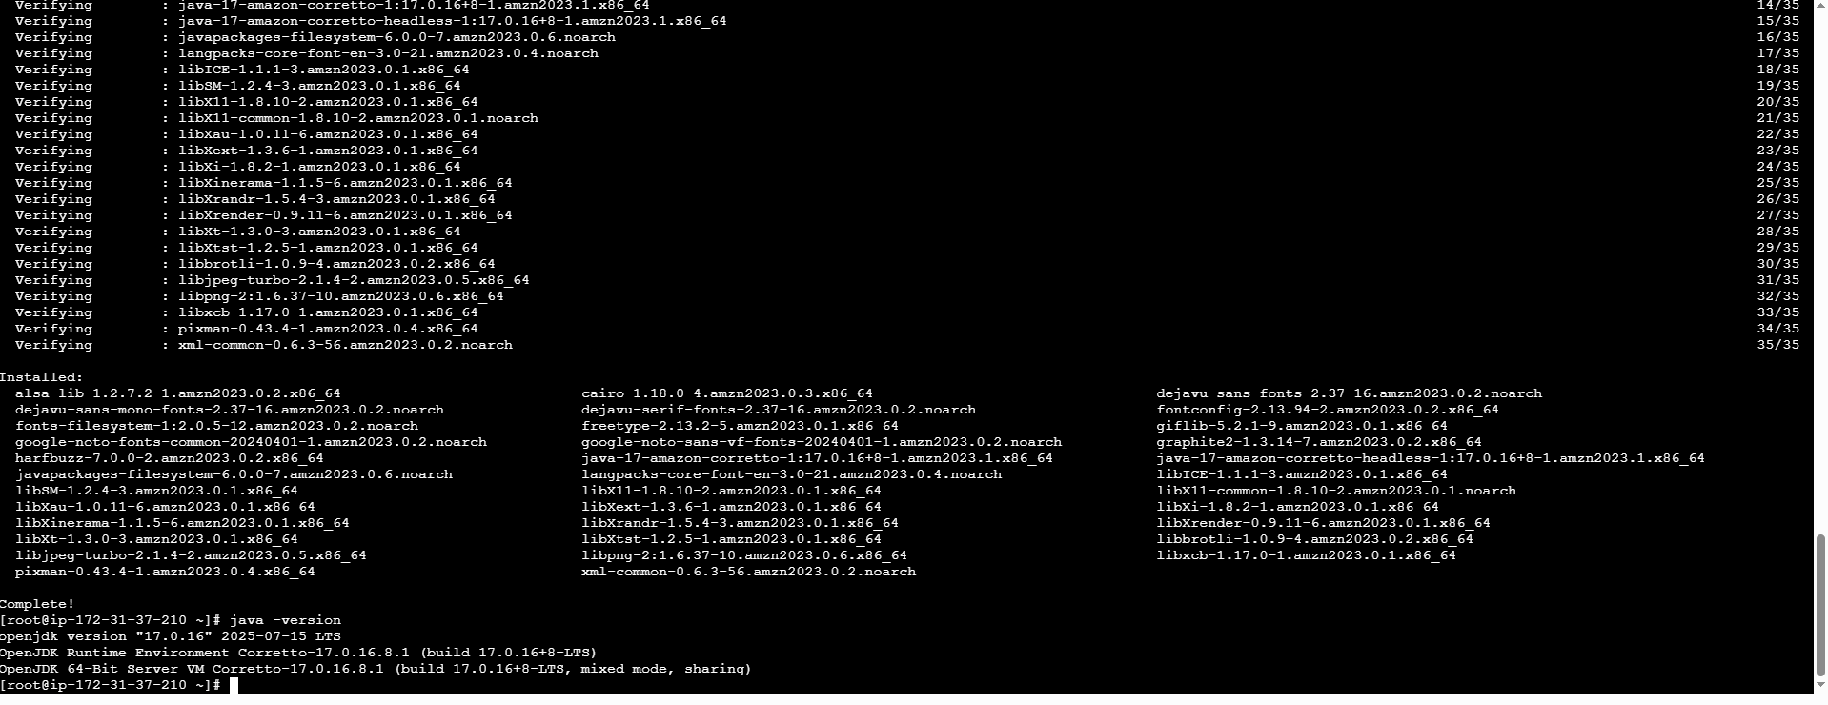
3. Add Jenkins Repository
sudo wget -O /etc/yum.repos.d/jenkins.repo https://pkg.jenkins.io/redhat-stable/jenkins.repo
sudo rpm --import https://pkg.jenkins.io/redhat-stable/jenkins.io-2023.key
4. Install Jenkins
sudo yum install jenkins –y
systemctl enable jenkins
systemctl start jenkins
systemctl status Jenkins
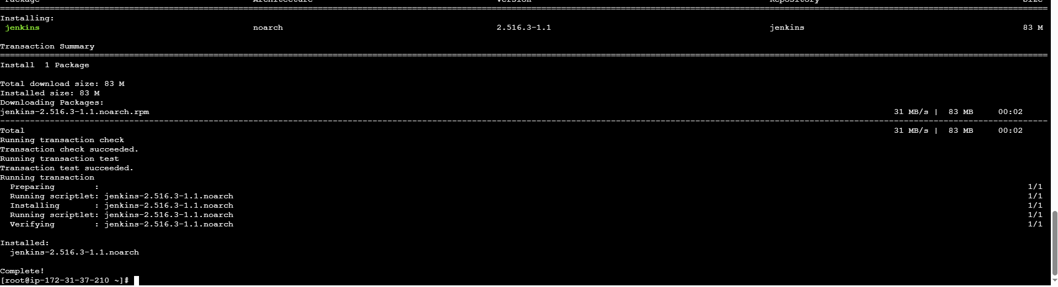
Step 2
Copy the data in Jenkins and put in Jenkins back-up
Cd /var/lib/Jenkins
Copy the file
Tar –cvf backup.tar Jenkins/
Vi master.pem
Give permission chmod 600 master.pem
Scp –I master.pem backup.tar ec2-user@<public id of backup Jenkins>/tmp

Step 3: Login in to new server and check the file in /tmp
Copy the file from tmp to /var/lib/jenkins/

Verify in browser
http://<EC2-Public-IP>:8080
after execution of above cmnds restart the Jenkins

Jenkins Master Server
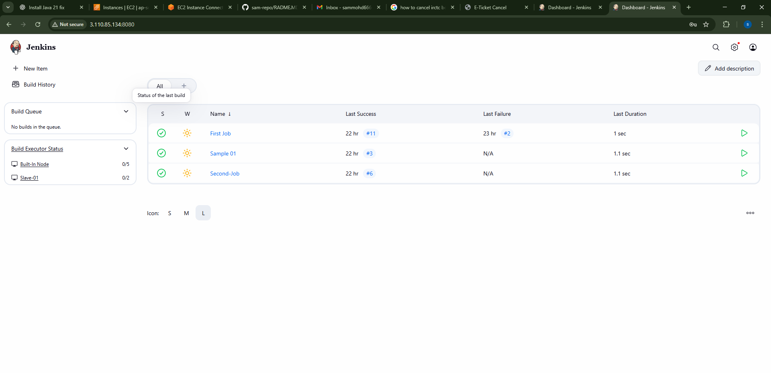
Backup Server
